
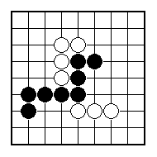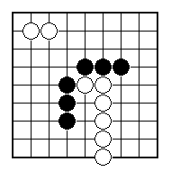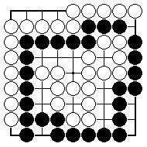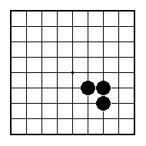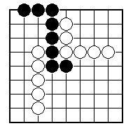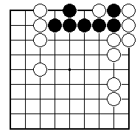
Are the black stones all connected together?

Are the black stones all connected together?

Are the black stones all connected together?

How many liberties does the black group have?

How many liberties does the black group have?

How many liberties does the black group have?

NAME:
BRITISH GO ASSOCIATION CERTIFICATE LEVEL 1 - SHEET 2

GROUPS AND LIBERTIES

